Mr. Visca – AP Calculus AB

Unit 2: Limits and Continuity Unit Review Notes

**Average Speed**

ratio: =

**Instantaneous Speed**

**Definition of a Limit**

Find the limits:

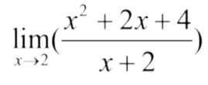

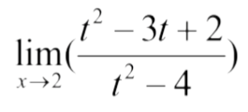

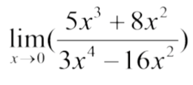

**1 sided vs 2 sided limits**

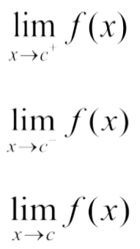

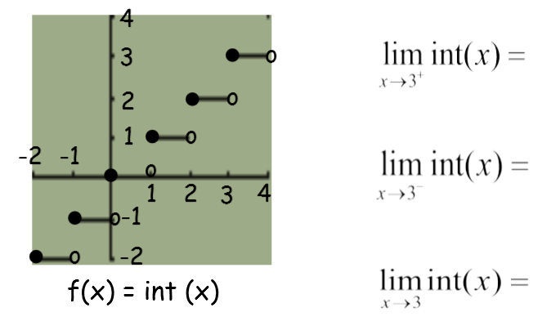

**Limits as x approaches +/- infinity**

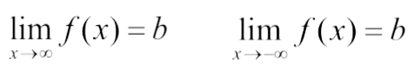

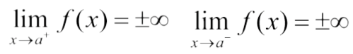

**Continuity**

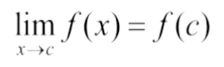

Given the graph below, is f(x) continuous at x = 1? x = ½?

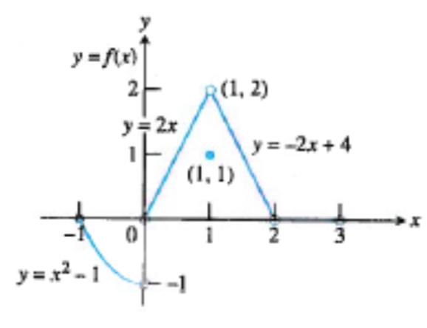

**Types of Discontinuity**

Hole, jump, infinite (asymptote)

**Intermediate Value Theorem for Continuous Functions**

If a function is continuous from [a,b], then there is a value in-between, x = c, where f(c) exists

**Average Rate of Change:**

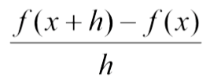

**Instantaneous Rate of Change:**

$$\underset{h→0}{lim⁡}{\frac{f\left(x+h\right)-f(x)}{h}}$$

**Equation of a line:**

Slope-intercept form:

Point-slope form:

Normal line:

Find the equation of the tangent line and normal line of the equation f(x) = 4 - x2, at the

point x = 1.



Meh…

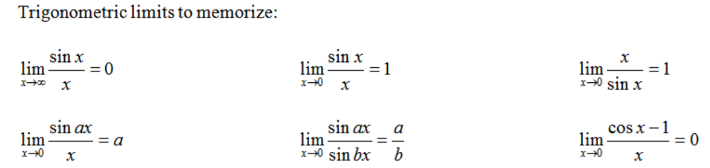

Part 1: No Calculator Allowed. Unit 2 REVIEW

Part A: A calculator may not be used on this part of the test.

1. =

1. If , then find 

3. 

4. Find the horizontal asymptote of .

5. 

6. What is ?

7. The graph of a function  is shown below. At which values of  (a,b,c,d,e) is continuous?

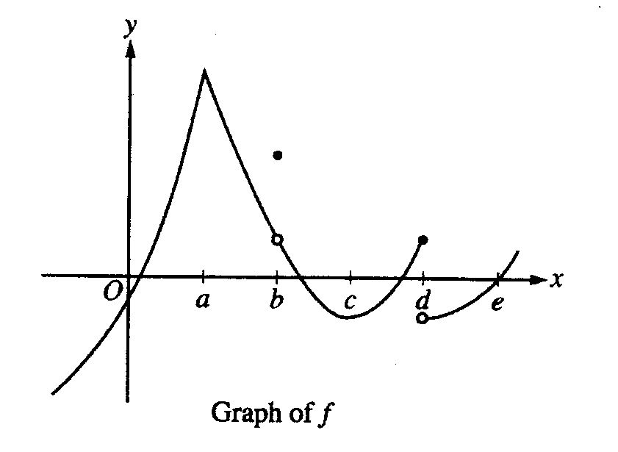

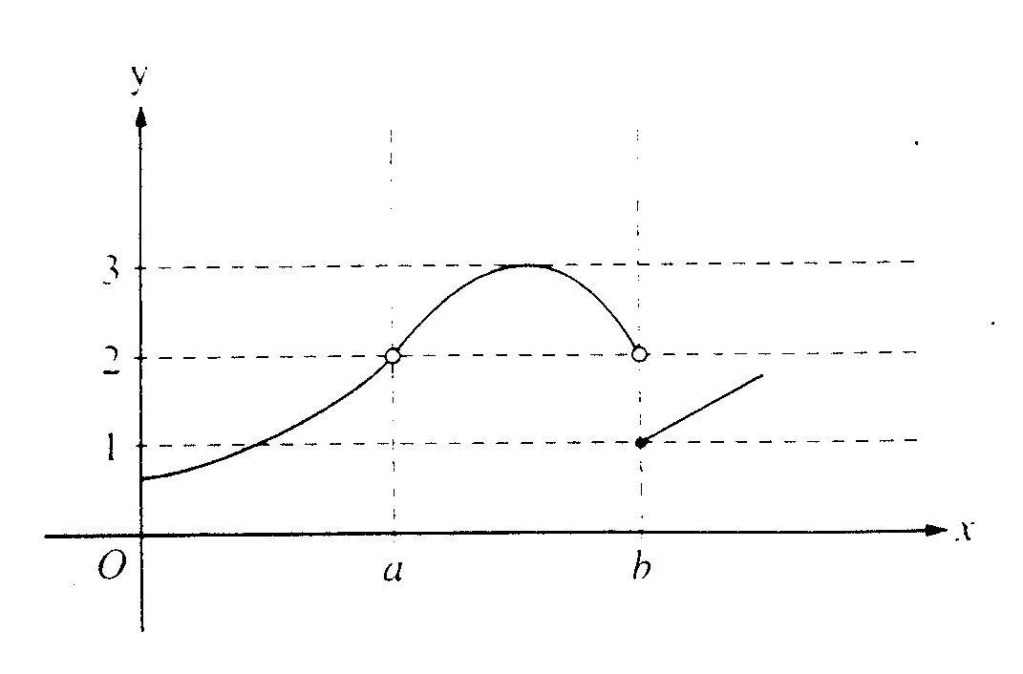8.

The graph of the function  is shown above. Which of the following statements is true?

(A) 

(B) 

(C) 

(D) 

(E) 

9. Let 

Find 

Is  continuous at x = 5?

10. If  find 

11. What is the average rate of change of the function  given by  on the closed

interval [1, 5]?

12. Given the function , use the intermediate value theorem to show that the equation  must have at least two solutions in the interval [-1, 4].

Part 2: A graphing calculator is required for some of the questions on this part of the test.

13. Let  be the function given by . Find  and .

14. Consider  when *x* = –4.

a) Find the slope of the curve at that point.

b) Write the equation of the tangent line at that point.

c) Write the equation of the normal to the curve at that point.